**Separate Module Dependencies With Adapter**

|  |  |  |
| --- | --- | --- |
| *a server class directly implements an evolving client interface* |  | *use an Adapter to break the dependency upon the client related interface* |

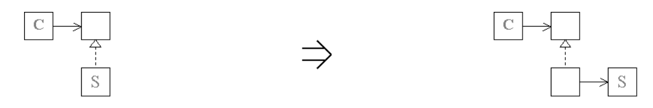

**Context:**  
[Separate Module Dependencies With Adapter](https://web.archive.org/web/20090914101235/http:/www.refactoring.be/thumbnails/rtn-smdwa.html) is an example of [Introduce Indirection](https://web.archive.org/web/20090914101235/http:/www.refactoring.be/thumbnails/rtn-ii.html) where the indirection is used to break the dependency between the server class an a client-bound interface, thus enabling the interface to evolve with the client, without requiring server implementation to be updated. Separating the server implementation from dependencies on client bound interfaces effectively decouples a server implementation from its context thereby promoting future reuse.